Notify Subscribers API before real-time streaming
In EVP, you can create API subscriptions to receive automatic notifications whenever specific terminal events occur. Before leveraging real-time streaming via WebSocket, the application must first subscribe to the desired events. Once subscribed, those events will be delivered to the client over an active WebSocket connection. Without subscription, no event data will be streamed.
Streamable Events
The following list of events are the possible N4 events that can be subscribed to and have a websocket stream:
Agent | EventType | ServiceOrder
AppointmentQuotaRule | Facility | ServiceOrderItem
AppointmentTimeSlot | Flag | Shipper
BillOfLading | FlagType | TbdUnit
BlItem | GateAppointment | TrainVisit
Booking | GenericEntity | TruckingCompany
CarrierItinerary | HandlingCode | TruckTransaction
CarrierService | HazardItem | TruckVisit
ChargeableAppointmentEventPayload | Hazards | TruckVisitAppointment
ChargeableMarineEvent | ItemServiceType | TruckVisitStats
ChargeableUnitEvent | ItemServiceTypeUnit | Unit
Che | LineOperator | UnitRecap
ChePool | MoveEvent | Vessel
Complex | Operator | VesselBerthing
DynamicEntity | PackageType | VesselClass
EcEvent | Placard | VesselVisit
EdiBatch | PointCall | VesselVisitLine
EdiTradingPartner | PointOfWork | Veto
EqBaseOrder | ProductType | VisitItinerary
EqBaseOrderItem | RailcarPlatform | WorkAssignment
EquipmentOrder | RailcarVisit | WorkInstruction
EquipmentOrderItem | RailRoad | WorkQueue
EquipType | RefCountry | WorkShift
Event | RefState | Yard

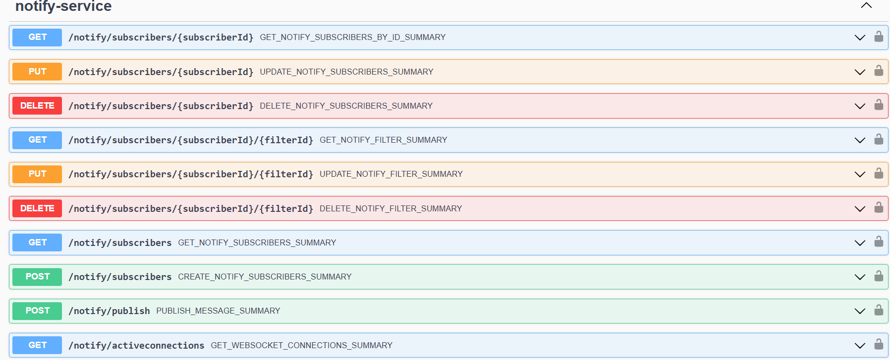

Creating a Subscription in Postman with filtering
In this section we will show you how to create a subscription in Postman that will allow you to stream data when a truck leaves Port Houston with an empty container.

Step 1: Create a POST URL against the notify endpoint of https://api.america.naviscloudops.com/v3/evp/notify/subscribers
Step 2: Create the Request Body. For this example, we’ll be using a standard filter that can be used as a generic template for building additional subscriptions. For more information, please use the API developer guide.
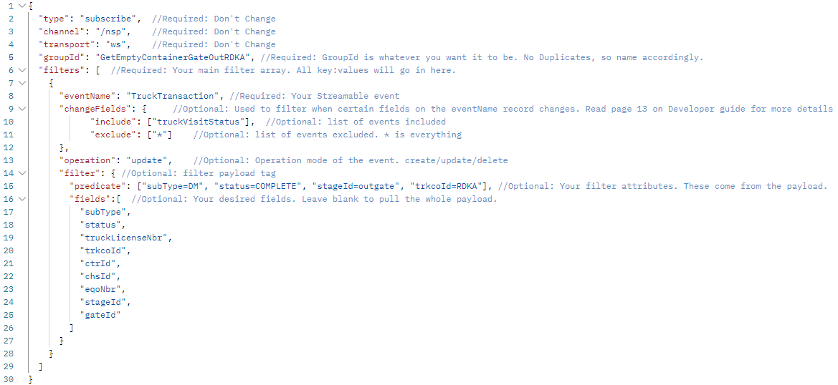
Step 3: Once you post the subscription, you will get a 200 OK response with the body you sent, as well as a subscription “id”, your “groupId”, and “filterId”. You will need the subscription id and your groupId to create the websocket. The filterId is used if you’d like to make changes to the filterId via an API endpoint. We’ll go over this later.
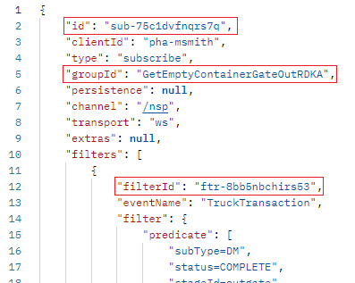
Step 4: Build the websocket using URL wss://api.america.naviscloudops.com/v3/evp/notify/stream? This URL takes in two parameters.
- Id=YOUR_SUBSCRIPTION_ID
- groupId=YOUR_GROUP_ID
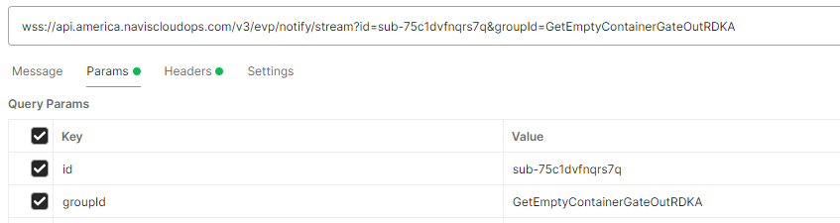
Step 5: Connect to the stream and validate messages. Please note you will have a small backlog in messages due to the time you set up the POST and when you set up the WebSocket, so please wait until backlog completes.
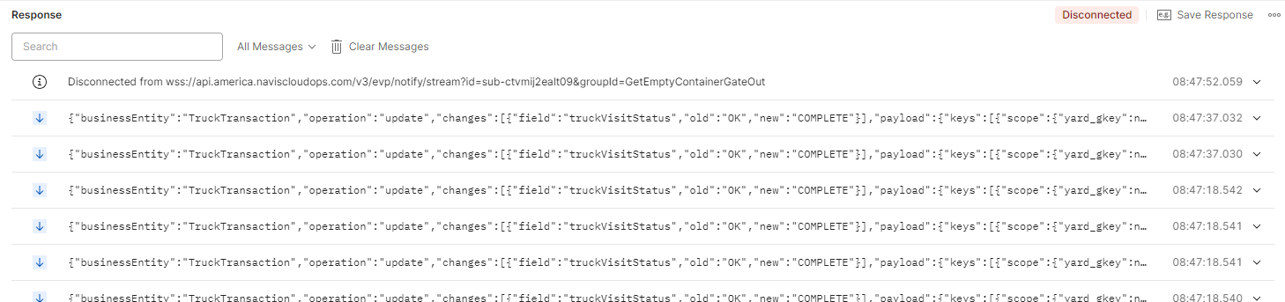

Deleting a subscription or filter in Postman
In this section we will show you how to delete a subscription or a filter in Postman.
Step 1: Use the DELETE operation on URL https://api.america.naviscloudops.com/v3/evp/notify/subscribers. This URL takes one or two parameters.
- subscriberId=YOUR_SUBSCRIPTION_ID
OR
- filterId=YOUR_FILTER_ID
Example: https://api.america.naviscloudops.com/v3/evp/notify/subscribers/sub-75c1dvfnqrs7q will delete the above example subscription
This same format applies to deleting filters in the subscription, just plug in your filterId after your subscriptionId.

Updating a Subscription or filter in Postman
In this section we will show you how to update a subscription in Postman that will allow you add/change additional filtering to an already made subscription, without having to delete the subscription.
Step 1: We will create a generic subscription that will send us updates every time a bookings tally is updated.
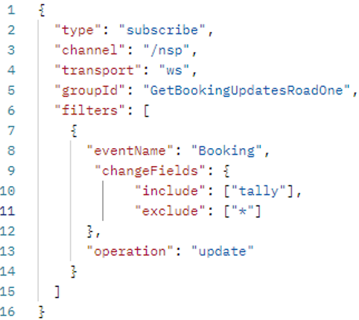
Step 2: We create the subscription and get the subscriptionId and filterId.
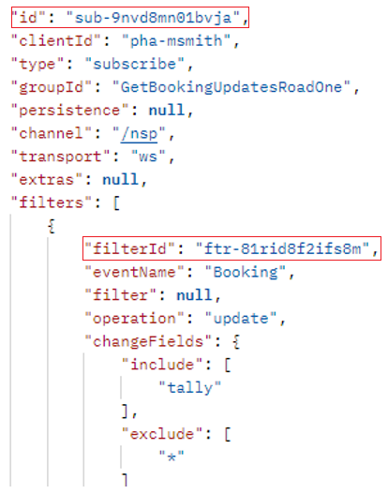
Step 3: We create a PUT request to the URL https://api.america.naviscloudops.com/v3/evp/notify/subscribers that includes our desired subscriberId and filterId.
https://api.america.naviscloudops.com/v3/evp/notify/subscribers/sub-9nvd8mn01bvja/ftr-81rid8f2ifs8m
Step 4: In the body of the request, we call the filterId and update our filter with what we want changed. In this case, we want to just filter on the booking number instead of changes to the tally field.

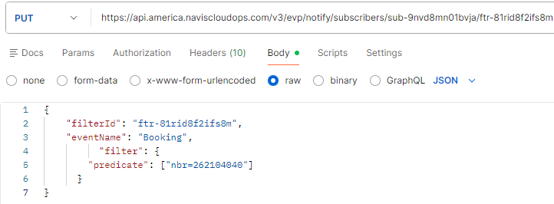
Step 5: Once we get a 200 OK message, we can now go back and check our subscription. Notice how our field changes are blank and our filter predicate is looking for a specific number.
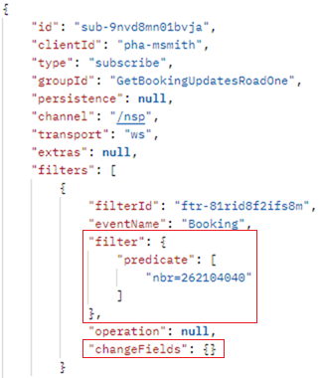

Additional Filtering Examples
In this example, we’ll create a filter that will send notifications when the stoppedRoad field changes on a unit that meets the predicate criteria.
eventName: "Unit" – subscribe to Unit events.
operation: "update" – only send notifications when a Unit is updated.
changeFields.include: ["stoppedRoad"] – only trigger when the stoppedRoad field changes.
predicate filters the Units:
transitState=S40_YARD
category=IMPRT
eqOwnerId=MAE
fields control which fields are returned in the notification payload:
unitId
impediments
